Name: Abrha Gebreslassie, Berhe

Subject: Lab Assignment - 2

**Problem - 1**

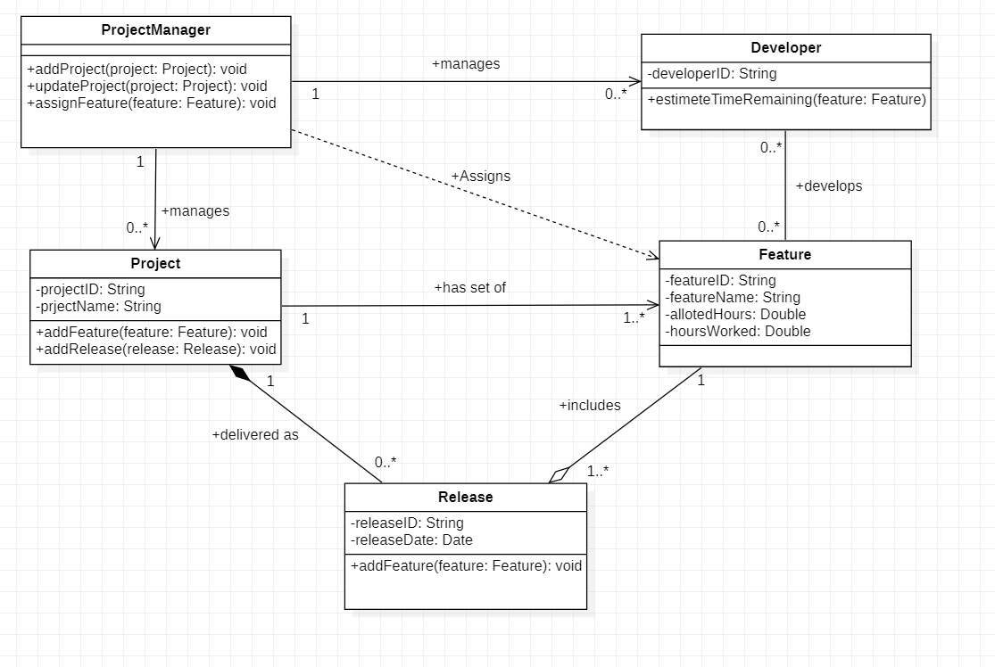

**Problem 2A Problem 2B**

